

Students at Montessori Noosa should:
- Feel safe
- Be safe
- Have fun
- Be happy
- Feel included

Montessori Noosa’s workplace health and safety officers are Amy Doyle and Clare de Graaf – they are available anytime if you need to talk to someone

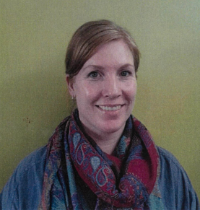

All Montessori Noosa staff are committed to providing a safe environment for students

